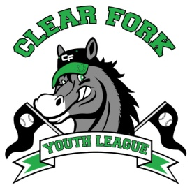
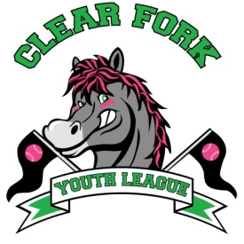
BOARD MEETING
JANUARY 9, 2019
Attendance:
Jay Vail
Mike Hoeflich
Josh Smith
Carrie Knight
Allen Leech
Ashley Ludwig
David Myers
Lindsay Roberts
Craig Smith

- Jay
  - Confirm upcoming dates
    - Registrations: January 14 – March 17
    - Skills and Drills: March 23 (Baseball 9-12, Softball 12-3)
    - Team Draft: March 25 @ New Life Church
  - Brainstormed possible coaches
  - Scholarship Fund
    - Brainstormed ways to determine who qualifies
  - Uniforms
    - Baseball hats
      - Will order extra to sell
    - Softball
      - Will get prices for headbands
  - Will make field sponsor signs out of plexi glass
  - Would like to have an opening day ceremony
    - Would include unveiling of Denny’s bench and also field sponsors
  - Jay and Nikki will make apparel to sell in the concession stand
    - We will pay them the cost to make items, all else is profit for the CFYL
  - Batting Cage
    - Getting a few more estimates on cost to build
    - Fundraisers to help fund the project
      - Bingo
      - Car wash
      - Selling apparel
      - Golf Tournament
      - 5K

- Allen
  - Bank Account looks good
  - PJ Hayes is making a memorial bench for Denny VanHouten
  - Agreed to a 2 year contract with Sharp Lawns for mowing and lawn care
  - Starting in 2019 anyone who earns money from us will need to fill out a W9, anyone who earns more than $600 in a calendar year will need to file a 1099

- Next Board Meeting February 13, 2019 7:00 @ Brumby’s

